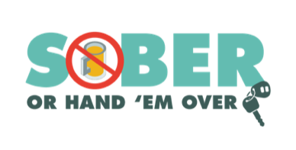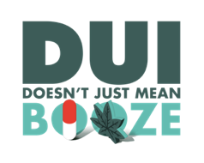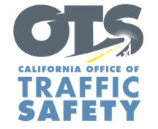

**FOR IMMEDIATE RELEASE**  August 19, 2025

Traffic Sgt. Matt Chavez

Mchavez@hemetca.gov

(951)765-2400

**The Hemet Police Department Reminds Drivers to   
Keep the Final Days of Summer Fun, Not Fatal**

Hemet, Calif. – As the end of summer approaches and families prepare for Labor Day celebrations, The Hemet Police Department reminds everyone to prioritize safety on the roads. Drivers are encouraged to make responsible choices behind the wheel by never driving under the influence of alcohol and/or drugs.

According to the National Highway Traffic Safety Administration, 12,429 people were killed in drunk-driving crashes in 2023 — that’s one person every 42 minutes.

“We want everyone to enjoy their end-of-summer travels and Labor Day festivities, but it’s important to do so responsibly,” Sergeant Matt Chavez of the Hemet Police Department said. “Driving under the influence not only puts your life at risk but also endangers everyone else on the road. Our goal is to reduce preventable crashes and save lives.”

The Hemet Police Department offers the following tips to Go Safely:

* **Plan Ahead**: If you know you’ll be drinking, arrange for a designated driver, use a ride-sharing service, taxi or public transportation.
* **Buckle Up**: Wearing a seatbelt is one of the simplest ways to protect yourself in the event of a crash.
* **Stay Alert**: Avoid distractions such as texting or eating while driving. Keep your focus on the road.
* **Follow Speed Limits**: Speeding reduces your reaction time and increases the severity of crashes.
* **Watch for Pedestrians and Bicyclists**: With more people enjoying outdoor activities, be extra vigilant and share the road responsibly.
* **Take Breaks**: If you’re traveling long distances, take regular breaks to rest and avoid fatigue.

To help keep our community safe, the Hemet Police Department will have additional officers on patrol Aug. 13 through Labor Day (Sept. 1) looking for drivers suspected of driving under the influence of alcohol and/or drugs. The additional efforts to prevent impaired driving are part of a national enforcement campaign*, Drive Sober or Get Pulled Over*.

While drunk driving is a significant traffic safety problem, driving while impaired is not just from alcohol. Prescription drugs, over-the-counter medications and cannabis products may also impair. If you plan on drinking or taking medications with a driving warning label, let someone who is sober drive. If you see someone who appears to be driving while impaired, call 9-1-1.

Visit [www.gosafelyca.org](http://www.gosafelyca.org) for more traffic safety information.

Funding for this program is provided by a grant from the California Office of Traffic Safety, through the National Highway Traffic Safety Administration.