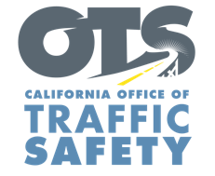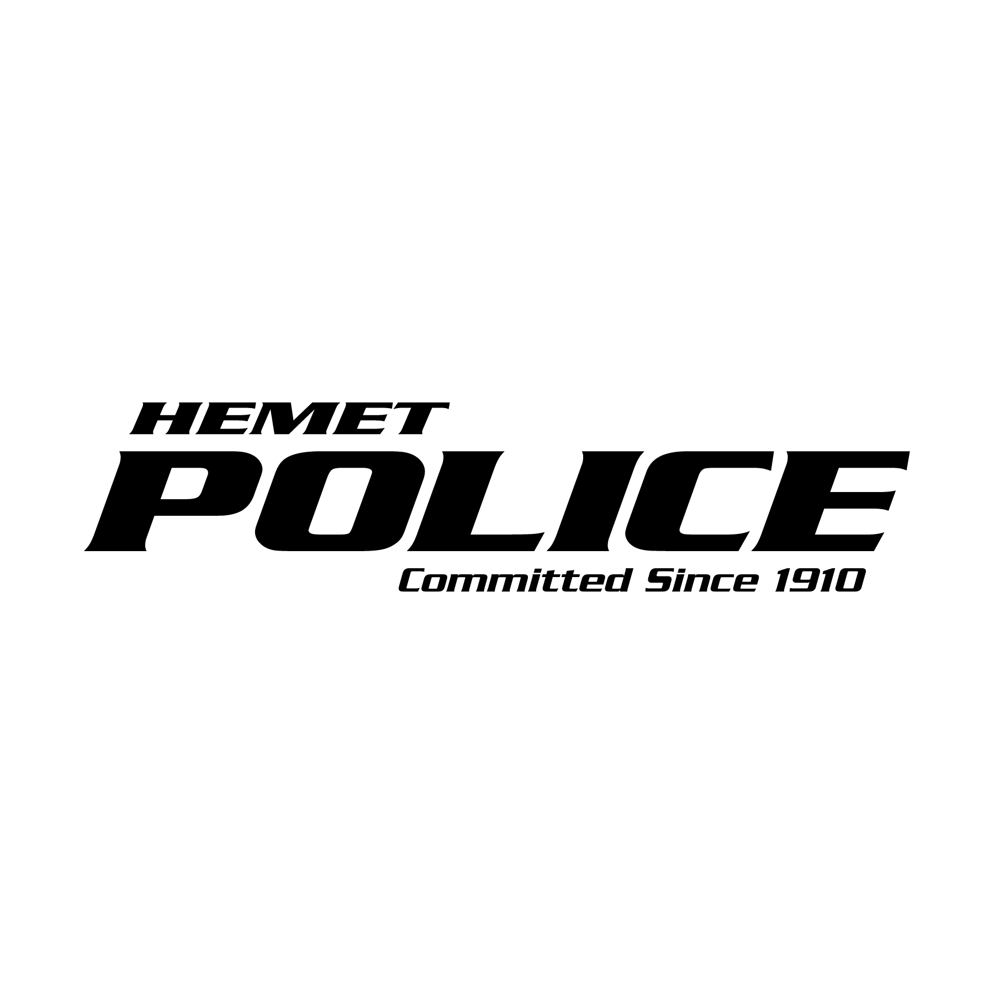

**FOR IMMEDIATE RELEASE**

Traffic Sgt. Gabriel Gomez May 24th, 2024

ggomez@hemetca.gov

(951) 765-3725

**“Click It or Ticket” Campaign Reminds   
Californians to Always Buckle Up**

*Seat Belt Safety Campaign Runs Through Memorial Day*

Hemet, Calif. – For Memorial Day Weekend, the Hemet Police Department reminds travelers to always buckle up and secure children in the right car seats when visiting friends and family.

This year’s *Click It or Ticket* campaign runs from May 20 to June 2. During this time, the Hemet Police Department will have additional officers on patrol actively looking for drivers and passengers who are not wearing a seat belt. This includes vehicles where children are not secured in child safety seats or the right safety seats for their age.

“Wearing a seat belt should be automatic for all drivers and passengers every trip,” Sgt. Gabriel Gomez said. “Seat belts save lives, and everyone — front seat and back, child and adult — needs to remember always to buckle up.”

According to the National Highway Traffic Safety Administration (NHTSA), nearly 12,000 people killed in crashes throughout the country in 2021 were not wearing seat belts. In California, 878 people killed in crashes in 2021 were not wearing seat belts, an increase of 12.3 percent from 2020.

California law requires a child to be secured in a safety or booster seat until they are at least 8 years old or at least 4 feet, 9 inches tall. Children under the age of 2 must ride in a rear-facing seat unless the child weighs 40 or more pounds or is 40 or more inches tall.

Funding for this program was provided by a grant from the California Office of Traffic Safety, through the National Highway Traffic Safety Administration.



