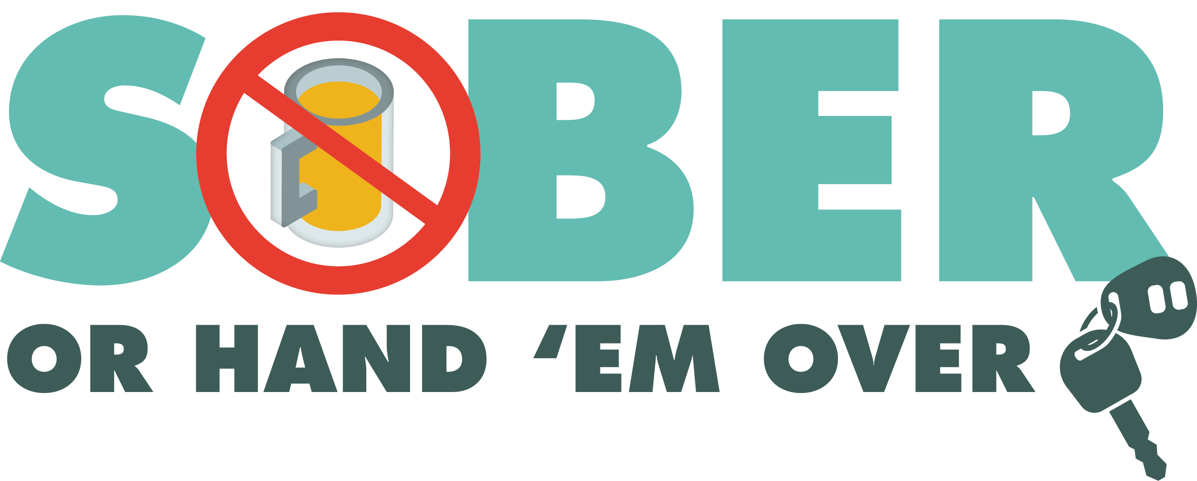

FOR IMMEDIATE RELEASE

DATE: April 22nd, 2024
CONTACT: Sergeant Gabriel Gomez
PHONE: (951) 634-3037
EMAIL: ggomez@hemetca.gov

PREPARED BY: Sergeant Gabriel Gomez

2 Arrested 12 Cited at Hemet Police DUI Checkpoint

Hemet, Calif. – On April 18th, 2024, 2 drivers were arrested for DUI and 12 citations were issued at a DUI checkpoint. 12 drivers were cited for operating a vehicle unlicensed or with a suspended/revoked license, 649 vehicles were contacted in total.

The DUI checkpoint was held within the 2400 block of W. Florida Avenue from 8:00 PM until approximately 2:00 AM on April 19th.

DUI checkpoint locations are determined based on reported incidents of impaired driving-related crashes. The primary purpose of DUI checkpoints is to promote public safety by taking suspected impaired drivers off roads.

Funding for this checkpoint was provided by a grant from the California Office of Traffic Safety, through the National Highway Traffic Safety Administration.

# # #

