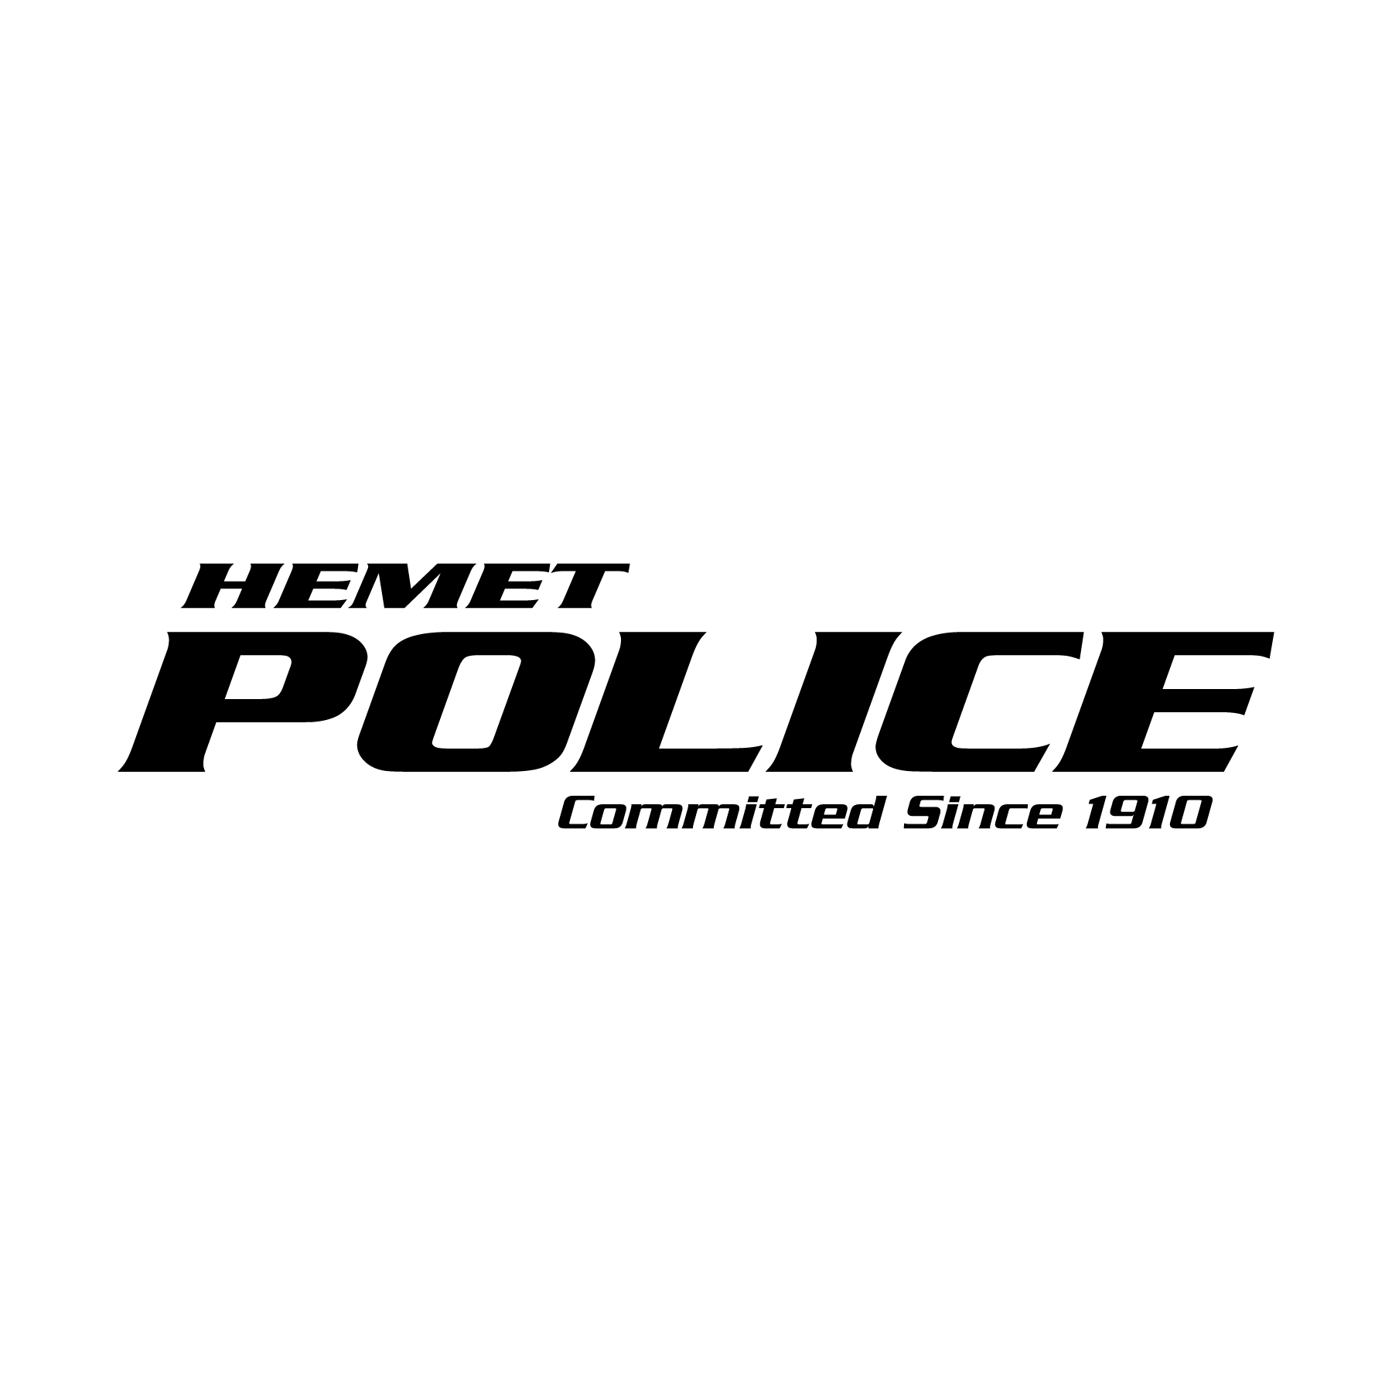
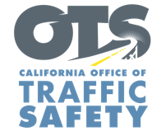

FOR IMMEDIATE RELEASE
Traffic Sgt. Gabriel Gomez April 2nd, 2024
ggomez@hemetca.gov
(951) 765-3725

Stay Focused, Stay Safe: Get Off Your Apps
April is Distracted Driving Awareness Month

Hemet, Calif. – April is Distracted Driving Awareness Month and a time to put safety in the driver’s seat. The Hemet Police Department will be actively looking for drivers throughout the month who are in violation of the state’s hands-free cell phone law.
"In today's fast-paced life, it is common to lose focus while driving,” the Hemet Police Department’s Sergeant Gabriel Gomez said. “Distracted Driving Awareness Month is a crucial reminder that even a moment of inattention or a quick glance at the phone can lead to serious consequences. Let’s get off our apps and keep our eyes on the road. Before starting the car, silence your phone or put it in the glove box, trunk or back seat. Anywhere you can’t reach."
According to the 2023 California Statewide Public Opinion Survey, more than 74% of drivers surveyed said that distracted driving because of texting was their biggest safety concern. In 2021, there were at least 140 people killed in distracted driving traffic crashes in California. The numbers are likely underreported because law enforcement officers may not always be able to tell that distraction was a factor in a crash.
Under current law, drivers are not allowed to hold a phone or electronic communications device while operating a vehicle, even when stopped at a red light. This includes talking, texting or using an app. Using a handheld cell phone while driving is punishable by a fine, and violating the hands-free law for a second time within 36 months of a prior conviction for the same offense will result in a point being added to a driver’s record.
If you have an important phone call, text or email, or are in a situation with other distractions, such as looking up directions, pull over to a safe parking spot to complete the task without putting yourself and others at risk. Other distractions can be eating, grooming, reaching for something that fell on the floor, putting on or taking off clothing, talking with passengers, or children in the back seat.

Funding for distracted driving enforcement is provided by a grant from the California Office of Traffic Safety, through the National Highway Traffic Safety Administration.

  

