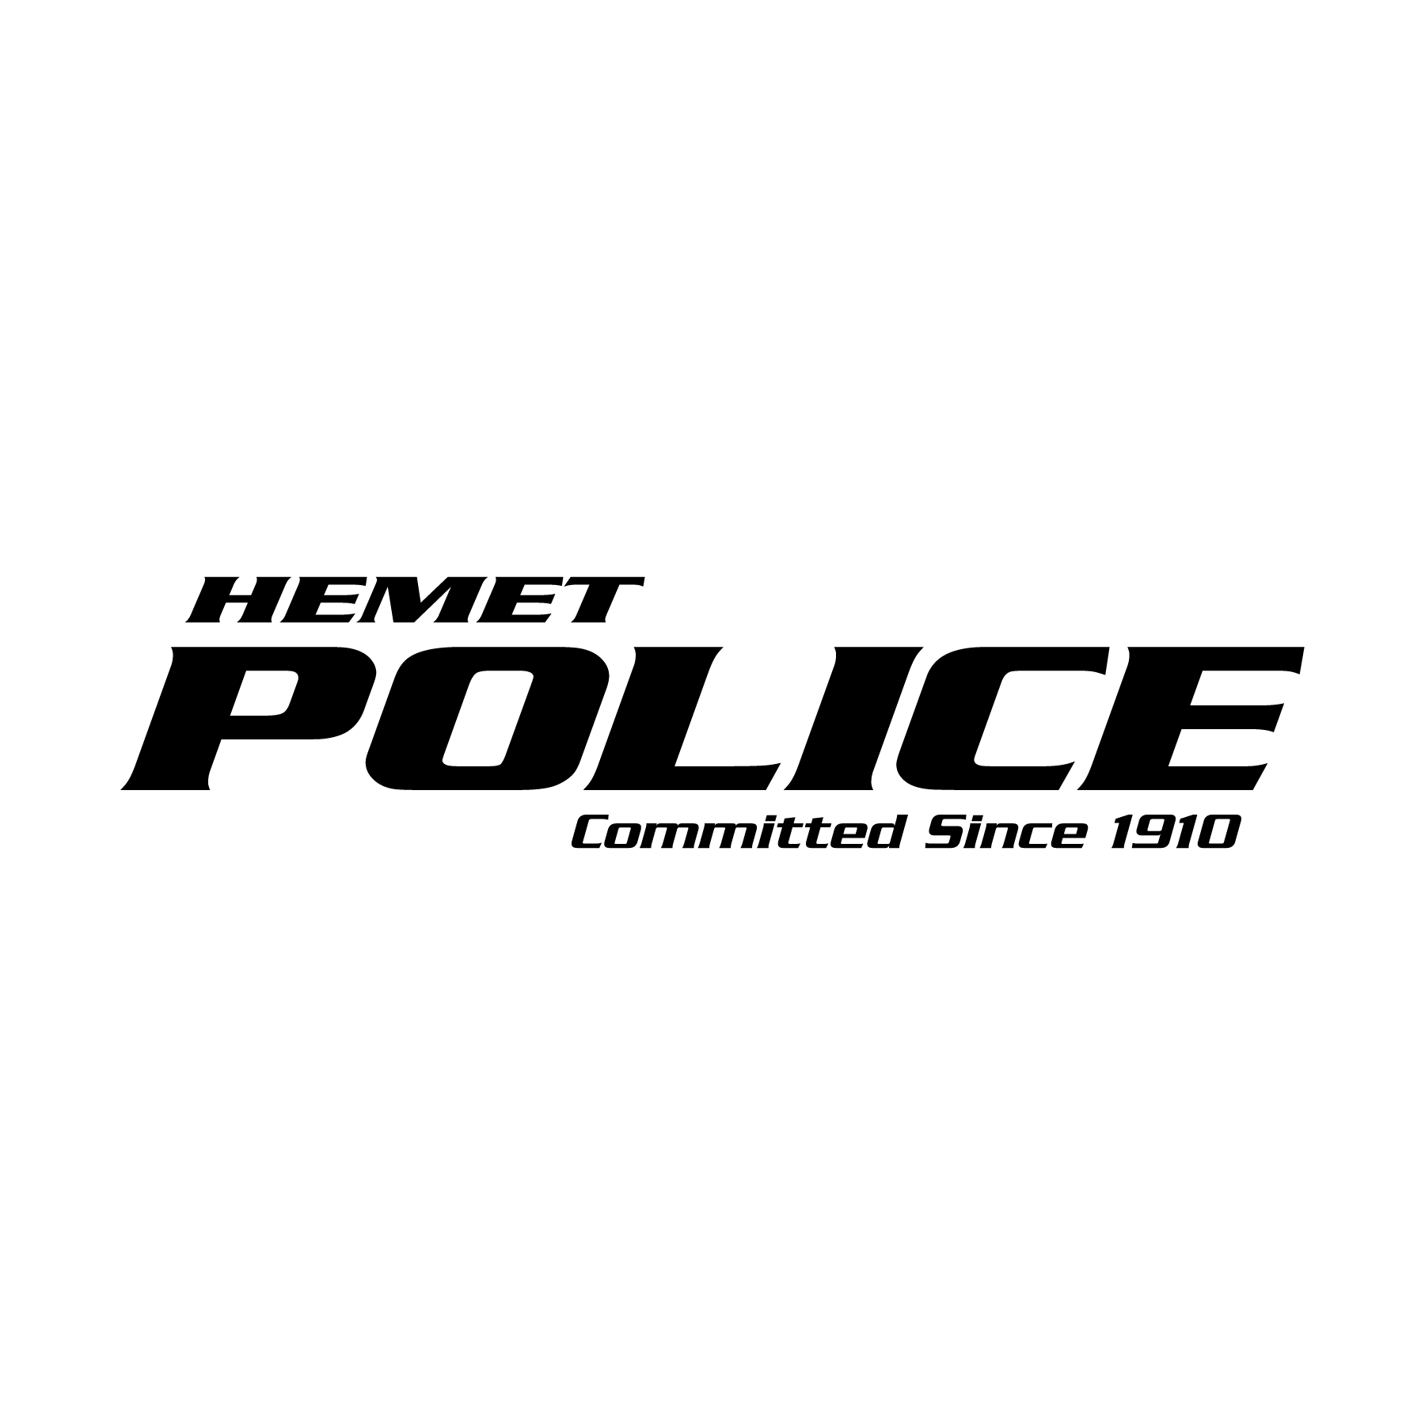
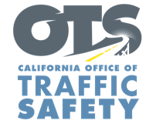

FOR IMMEDIATE RELEASE
Traffic Sgt. Gabriel Gomez March, 12th 2024
ggomez@hemetca.gov
(951) 765-3725

Celebrate this St. Patrick’s Day Responsibly:
Designate a Sober Driver, Your Lucky Charm

Hemet, Calif. – With the St. Patrick’s Day celebrations fast approaching, the Hemet Police Department will be on alert for suspected impaired drivers and reminds the community to celebrate responsibly by designating a sober driver - your lucky charm for a safe and enjoyable celebration.

“St. Patrick’s Day is a time for celebration, but it’s important to celebrate responsibly,” Hemet Police Traffic Corporal Cheyne Nicot said. “Designating a sober driver before the festivities begin can save lives. It's a simple way to make sure everyone traveling on our roads gets home safely."

According to the National Highway Traffic Safety Administration (NHTSA), St. Patrick’s Day is one of the deadliest times on our nation’s roads. More than 13,384 preventable deaths throughout 2021 involved drunk driving, representing 31% of all traffic fatalities in the United States that year. Over the 2021 St. Patrick’s Day holiday period, specifically, 47 people were killed in drunk-driving crashes in the U.S.

The Hemet Police Department’s Lt. Michael Mouat wants to warn the community that alcohol is not the only substance that can cause impairment. Marijuana, prescription medications or over-the-counter drugs may also impair. Do your research and understand how certain drugs may affect your driving ability.

Funding for this program is provided by a grant from the California Office of Traffic Safety, through the National Highway Traffic Safety Administration.



  

